Ocelot folder structure and package , project explanation
- Folder structure
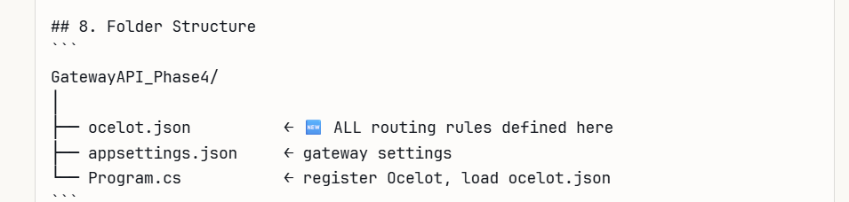

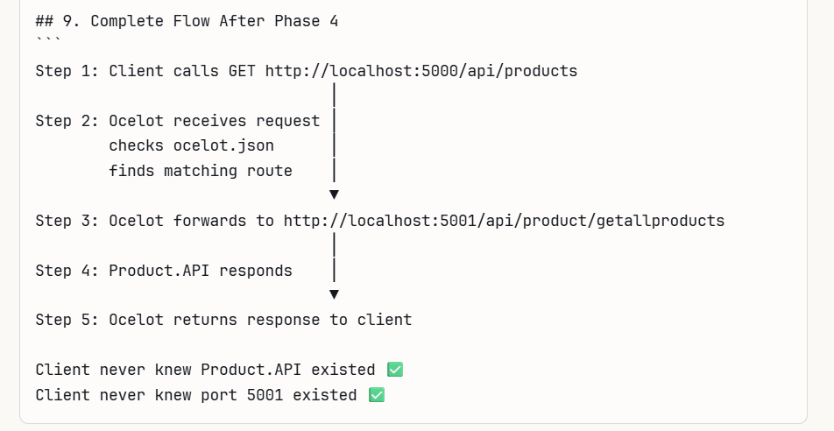
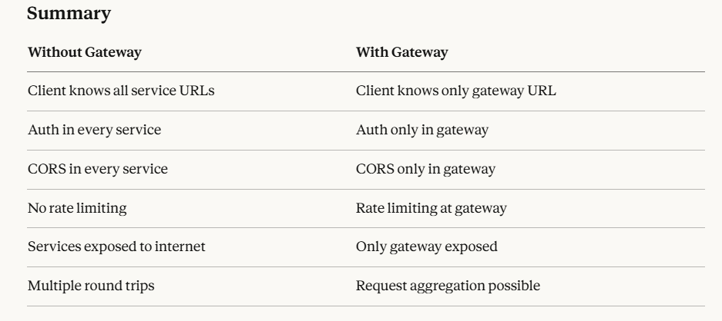

PROJECT EXECUTION EXPLANATION

Step 1 : create a new project named as “GatewayAPI_Phase4”
Step 2: Install Ocelot package
Step 3: Set port to 5000 in launchsettings.json
Step 4: verify the cproj(sdk) file is correctly modelled
Step 5 : Right click GatewayAPI_Phase4 project → Add → New Item → JSON File → name it exactly ocelot.json
Inside this json file give the routings of service path

Step 6: Program.cs - add code in the program.cs
await app.UseOcelot(); - this is the core line which makes the ocelot to run

